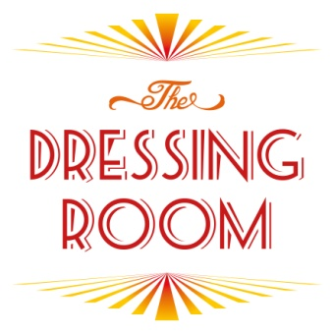
Order form
The Dressing Room Catering at The Edge

Please only edit boxes in grey and return to info@edgetheatre.co.uk
We normally require a minimum of 3 working days notice for food.

Organisation

Lead Booker

Contact number
Email
Today’s date

Date of room booking
Room to be served in

 |  | Quantity | Dietary requirements | Total £
Lunch
Option 1: Sandwich Lunch | £4.95/head
Option 2: Finger Food | £7.95/head
Option 3: Sandwich and Salad Lunch | £7.95/head
Option 4: Deluxe Lunch | £12.95/head
Option 5: Soup & Roll (only avail in winter) | £3.95/head
Total

Drinks |  | Quantity | Total £
Tea, coffee and herbal infusions | £1/head
Tea, coffee and herbal infusions | £3.50 unlimited for the day
Juice – apple | £3/jug
Juice – orange | £3/jug
Cans | £1/can
Still Water | £1/bottle
Sparkling Water | £1/bottle
Total

Other |  | Quantity | Total £
Crisps | 50p/head
Chips | £1/head
Breakfast roll –sausage | £3.45/head
Breakfast roll -bacon | £3.45/head
Danish pastries & croissants | £2/head
Selection of biscuits | £1/head
Fresh Fruit platter | £2.50/head
Traybakes | £2/head
Tea loaves | £2.50/head
Freshly baked Dressing Room Cakes | £3/head
Total

Total Cost

